ASSIGNMENT 3

1.
a.) Clustered column chart of per Vs post academy.(Test for each grade level)
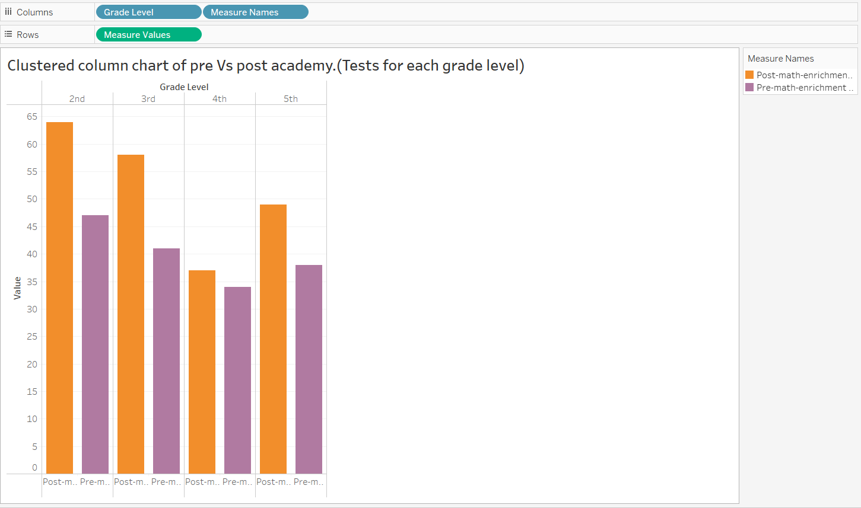
This figure looks at pre-math enrichment program test scores to post-math enrichment program test scores across a different grade level range from (2nd to 5th grade). We display the data in a bar graph where each pair of bars corresponds to a grade level and the first one (purple) shows the pre-program assessment scores and the second (orange) is the post-program assessment scores. The growth from pre to post means an upgrade in scores are observed following extracurricular activities program.
Moreover, the goal of this visual will be to show the growth or increase in test scores that occurred upon finishing the math enrichment program. An increase from pre to post reflects an improvement and or advancement in the math scores which depicts the success of the extracurricular activities program in boosting the students' math skills and knowledge acquisition.

b.) Slop chart for pre-Vs post academy tests for each grade level.
The slope chart helps us to visualize the alterations of pre-math-enrichment and post- math-enrichment scores in different grade levels. Its structure lets to visualize the development process, as the improvement is reflected in the linear or nonlinear growth between the assessments scores. Lines connecting the pre-test and post-test results for each level indicate the rate of improvement and point to the grades that received the largest grow during the enrichment program. While a shaded bar chart represents merely the magnitudes of change at various stages of student development, a slope chart allows a more sophisticated interpretation of the program's effect on standards test outcomes, by tracking the direction and amplitude of change for every grade level.

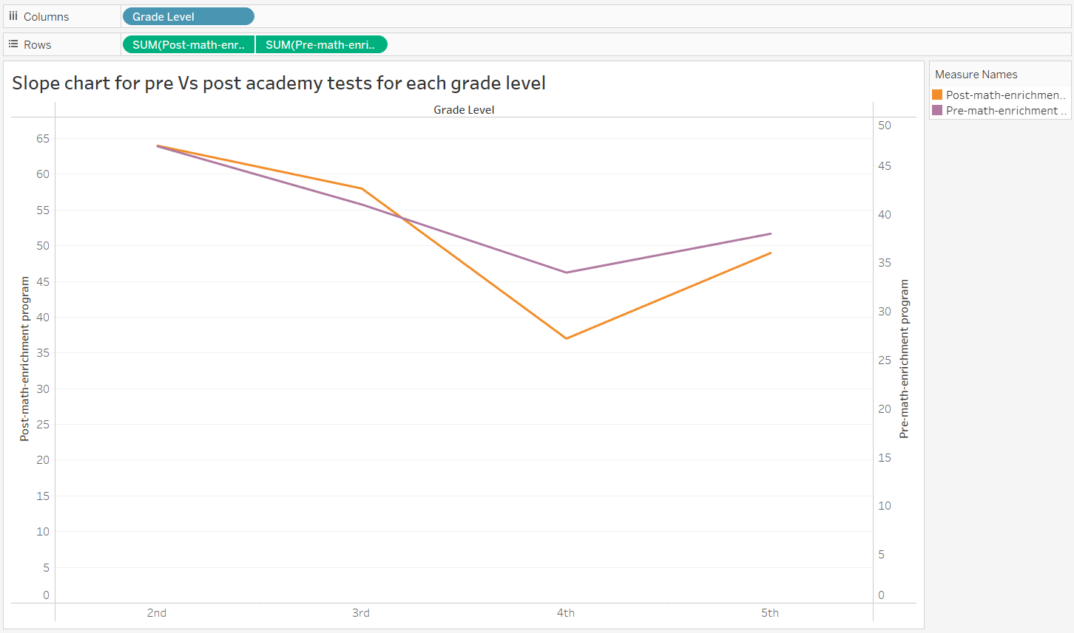
One of the main features of the slope chart is that it makes it possible to notice the grade levels that underwent the biggest transformations during the enrichment program. The graph provides a depiction of the levels of each grade with labels showing which grades achieved the highest growth in standardized test scores after participation in the program.

c.) Slope chart of grade-level test score improvement: Math Enrichment program.
In tableau, color, considered the pre-attentive attribute was skillfully mastered in the process of the ‘’grade level color’’ calculated field creation. A grade level color palette was established whereby brown was associated with the fourth grade whereas the rest of the elementary school grades (second, third and fifth) were represented by Red. This narrowed the attention of the audience on the changes in test scores that occurred in fourth grade and not the other levels. Trenchant utilisation of color was the key element which greatly contributed to the convenience of plotting the chart and increased its narration effect.
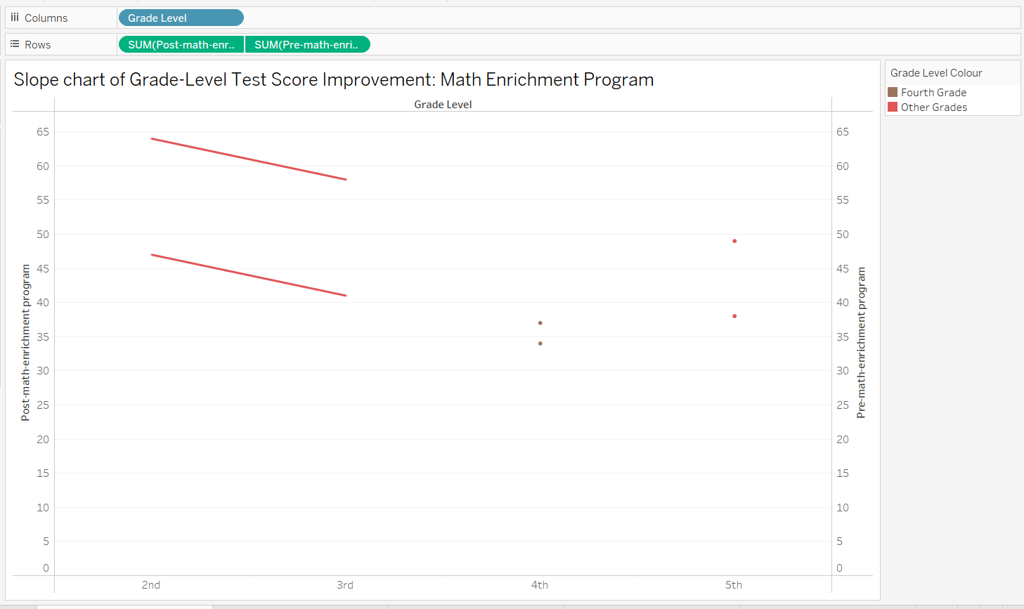

2.)
a.)
1. A stacked chart of donation solicitations by development officer and outcome.
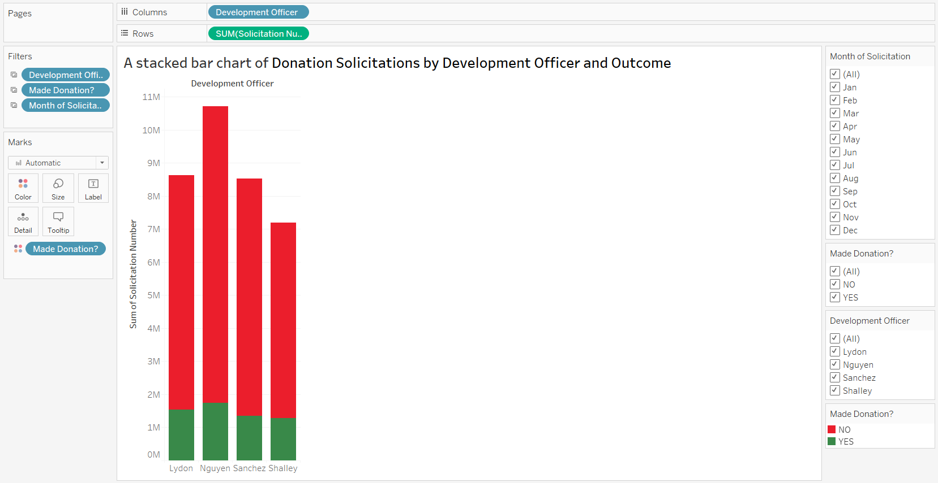

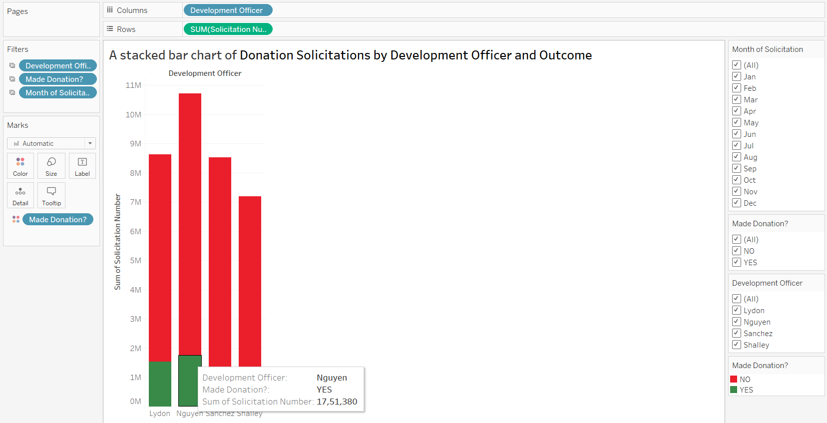
This stacked bar chart illustrates the number of solicitations made by various development officers (Lydon, Nguyen, Sanchez, Shalley) and the outcomes, indicating whether a donation was secured or not. Solicitations without a donation are depicted by red bars, while solicitations resulting in a donation are represented by green bars. From the graph, it is evident that development officer "Nguyen" has a higher success rate in securing donations, with approximately 17,51380 donations. Additionally, the chart highlights the number of proposals that did not result in gifts or pledges.

2.)
A Stacked bar of success rate of donation by mode of solicitations and outcome.

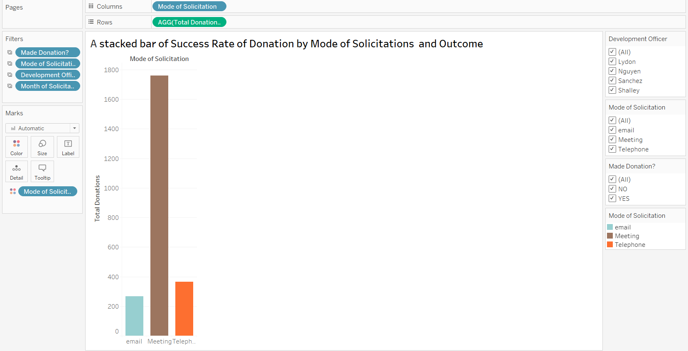

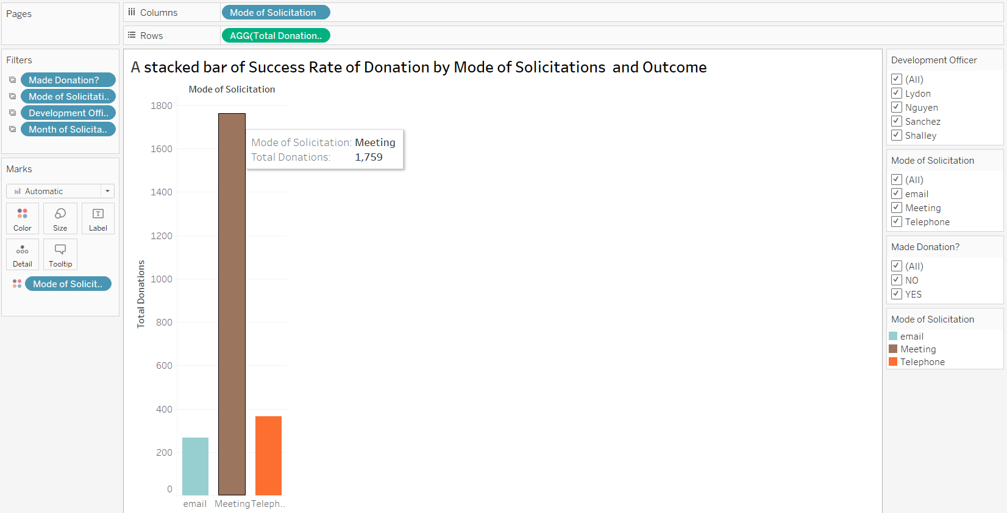
This histogram provides a visual representation of the success rate of donation solicitations across different modes of communication, namely email, meeting, and telephone, while also depicting the outcome of each solicitation. Each bar in the histogram represents the total donations secured through a particular mode of communication, allowing viewers to easily discern which method of solicitation was most effective in generating donations.
The mode of solicitation with the highest success rate in terms of donations secured is meetings. A total of 1,759 out of 1,800 donations were made through this mode.

3.)
A stacked bar chart of total donations by development officer and legacy designation.
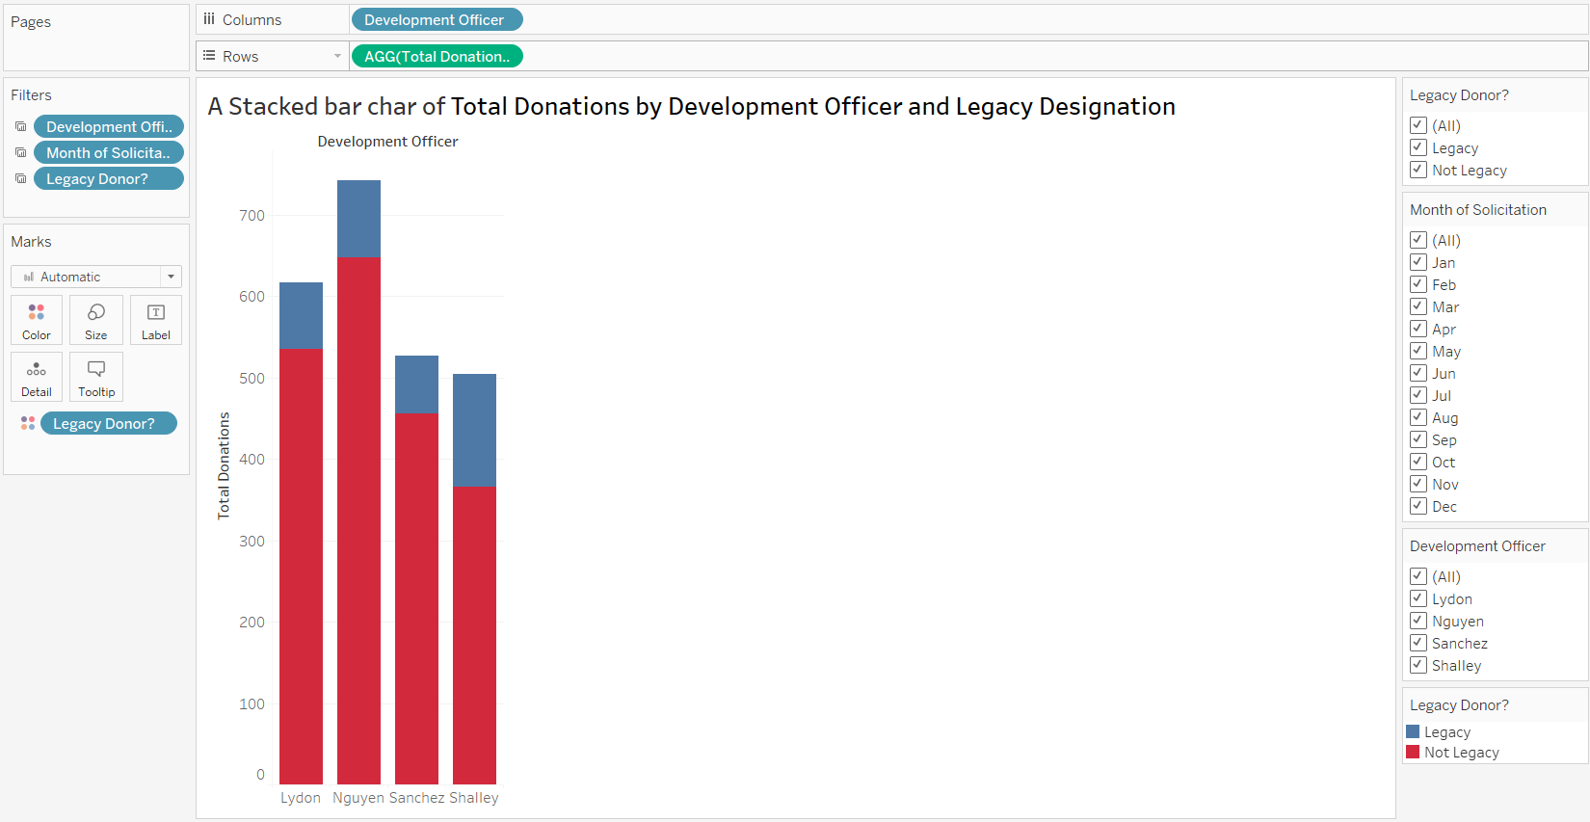
This stacked bar chart showcases the total donations received by individual development officers, detailing whether the donors were legacy donors or not. In each bar, the blue segment represents donations from legacy donors, while the red segment signifies donations from non-legacy donors.
The "Sanchez" stands out with the most balanced distribution between legacy and non-legacy donations, suggesting a diverse donor base. This balance is reflected in the total donations, which nearly range between 400 to 500.

4.)
A clustered bar chart of total donations by mode of solicitation and legacy designation.
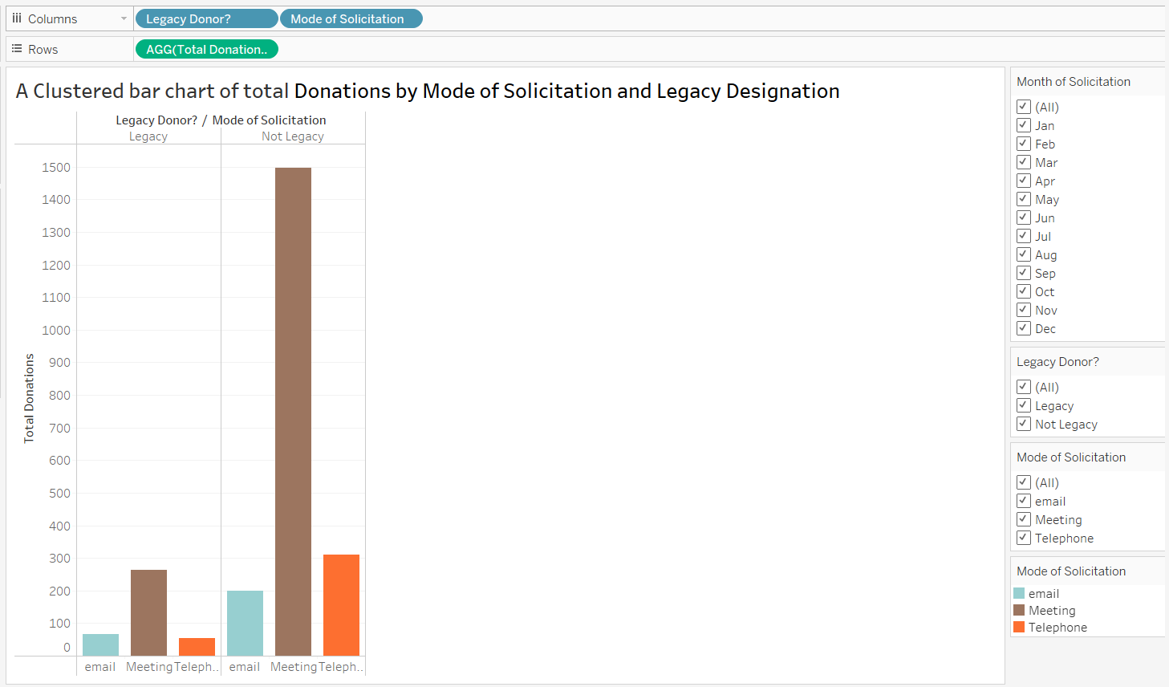
The most evident conclusion is the strong correlation between total donations and amount of generations when legacy designation is missing. We can use the bars as clusters shape where the one of them stands for the mode of solicitation with the donations' inheritance and the other one for the donations from neither inherited donors.
Such as telecommunication equivalent to legacy donations seems to turn out the most effective way of fundraising legacies from donors as the largest segment of these individuals show that legacy donations arise as the result of telecommunication. Conversely (there is a higher chance of the top tier legacy donors participating in high-end solicitation activities as compared to non-legacy group who also have more than their fair share of such type of treatment).
This might, in extreme cases, portray the traditional approach as unrealistic since the invididual talk often comes among the many other one-on-one interactions.
b.)
The Fundraising Performance Dashboard.
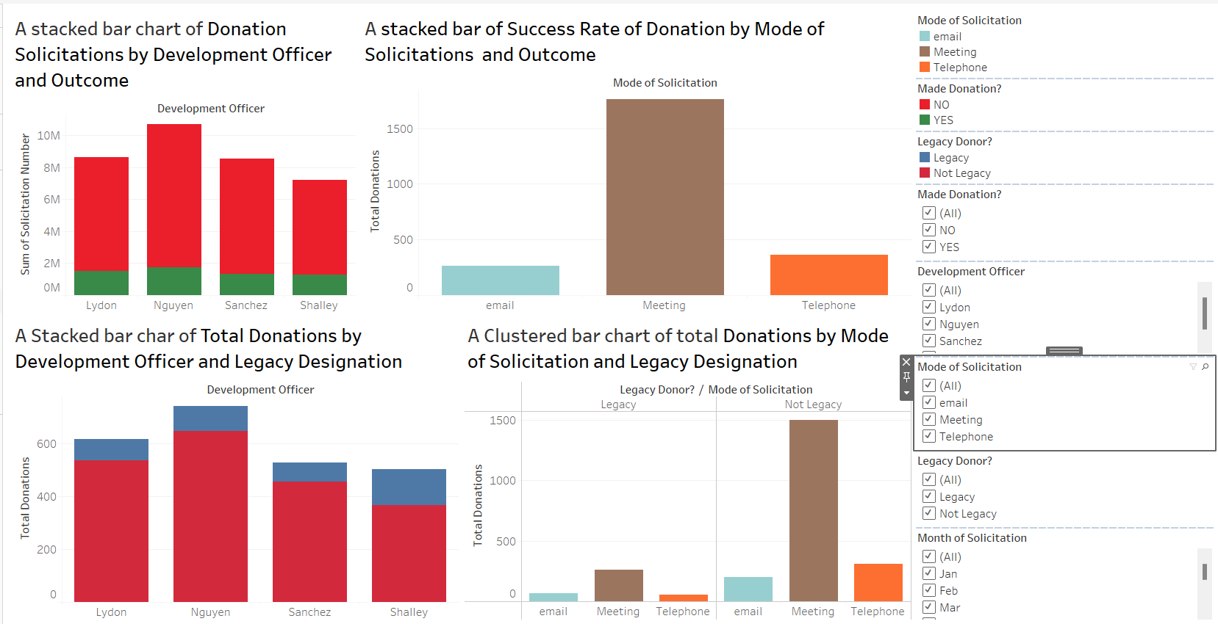

c.)
The above-mentioned screenshots show how each slicer was created according to the instructions.

d.)
Data Integration and Dashboard Update.
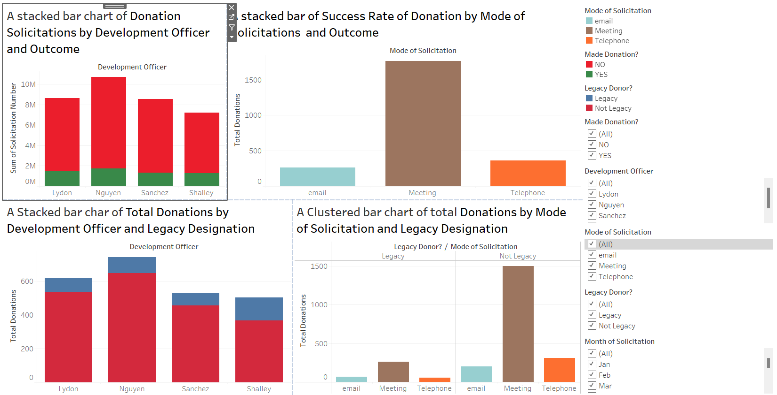

Name: - Raju Rishikesh Gollapally
Student Id: - 811285826

